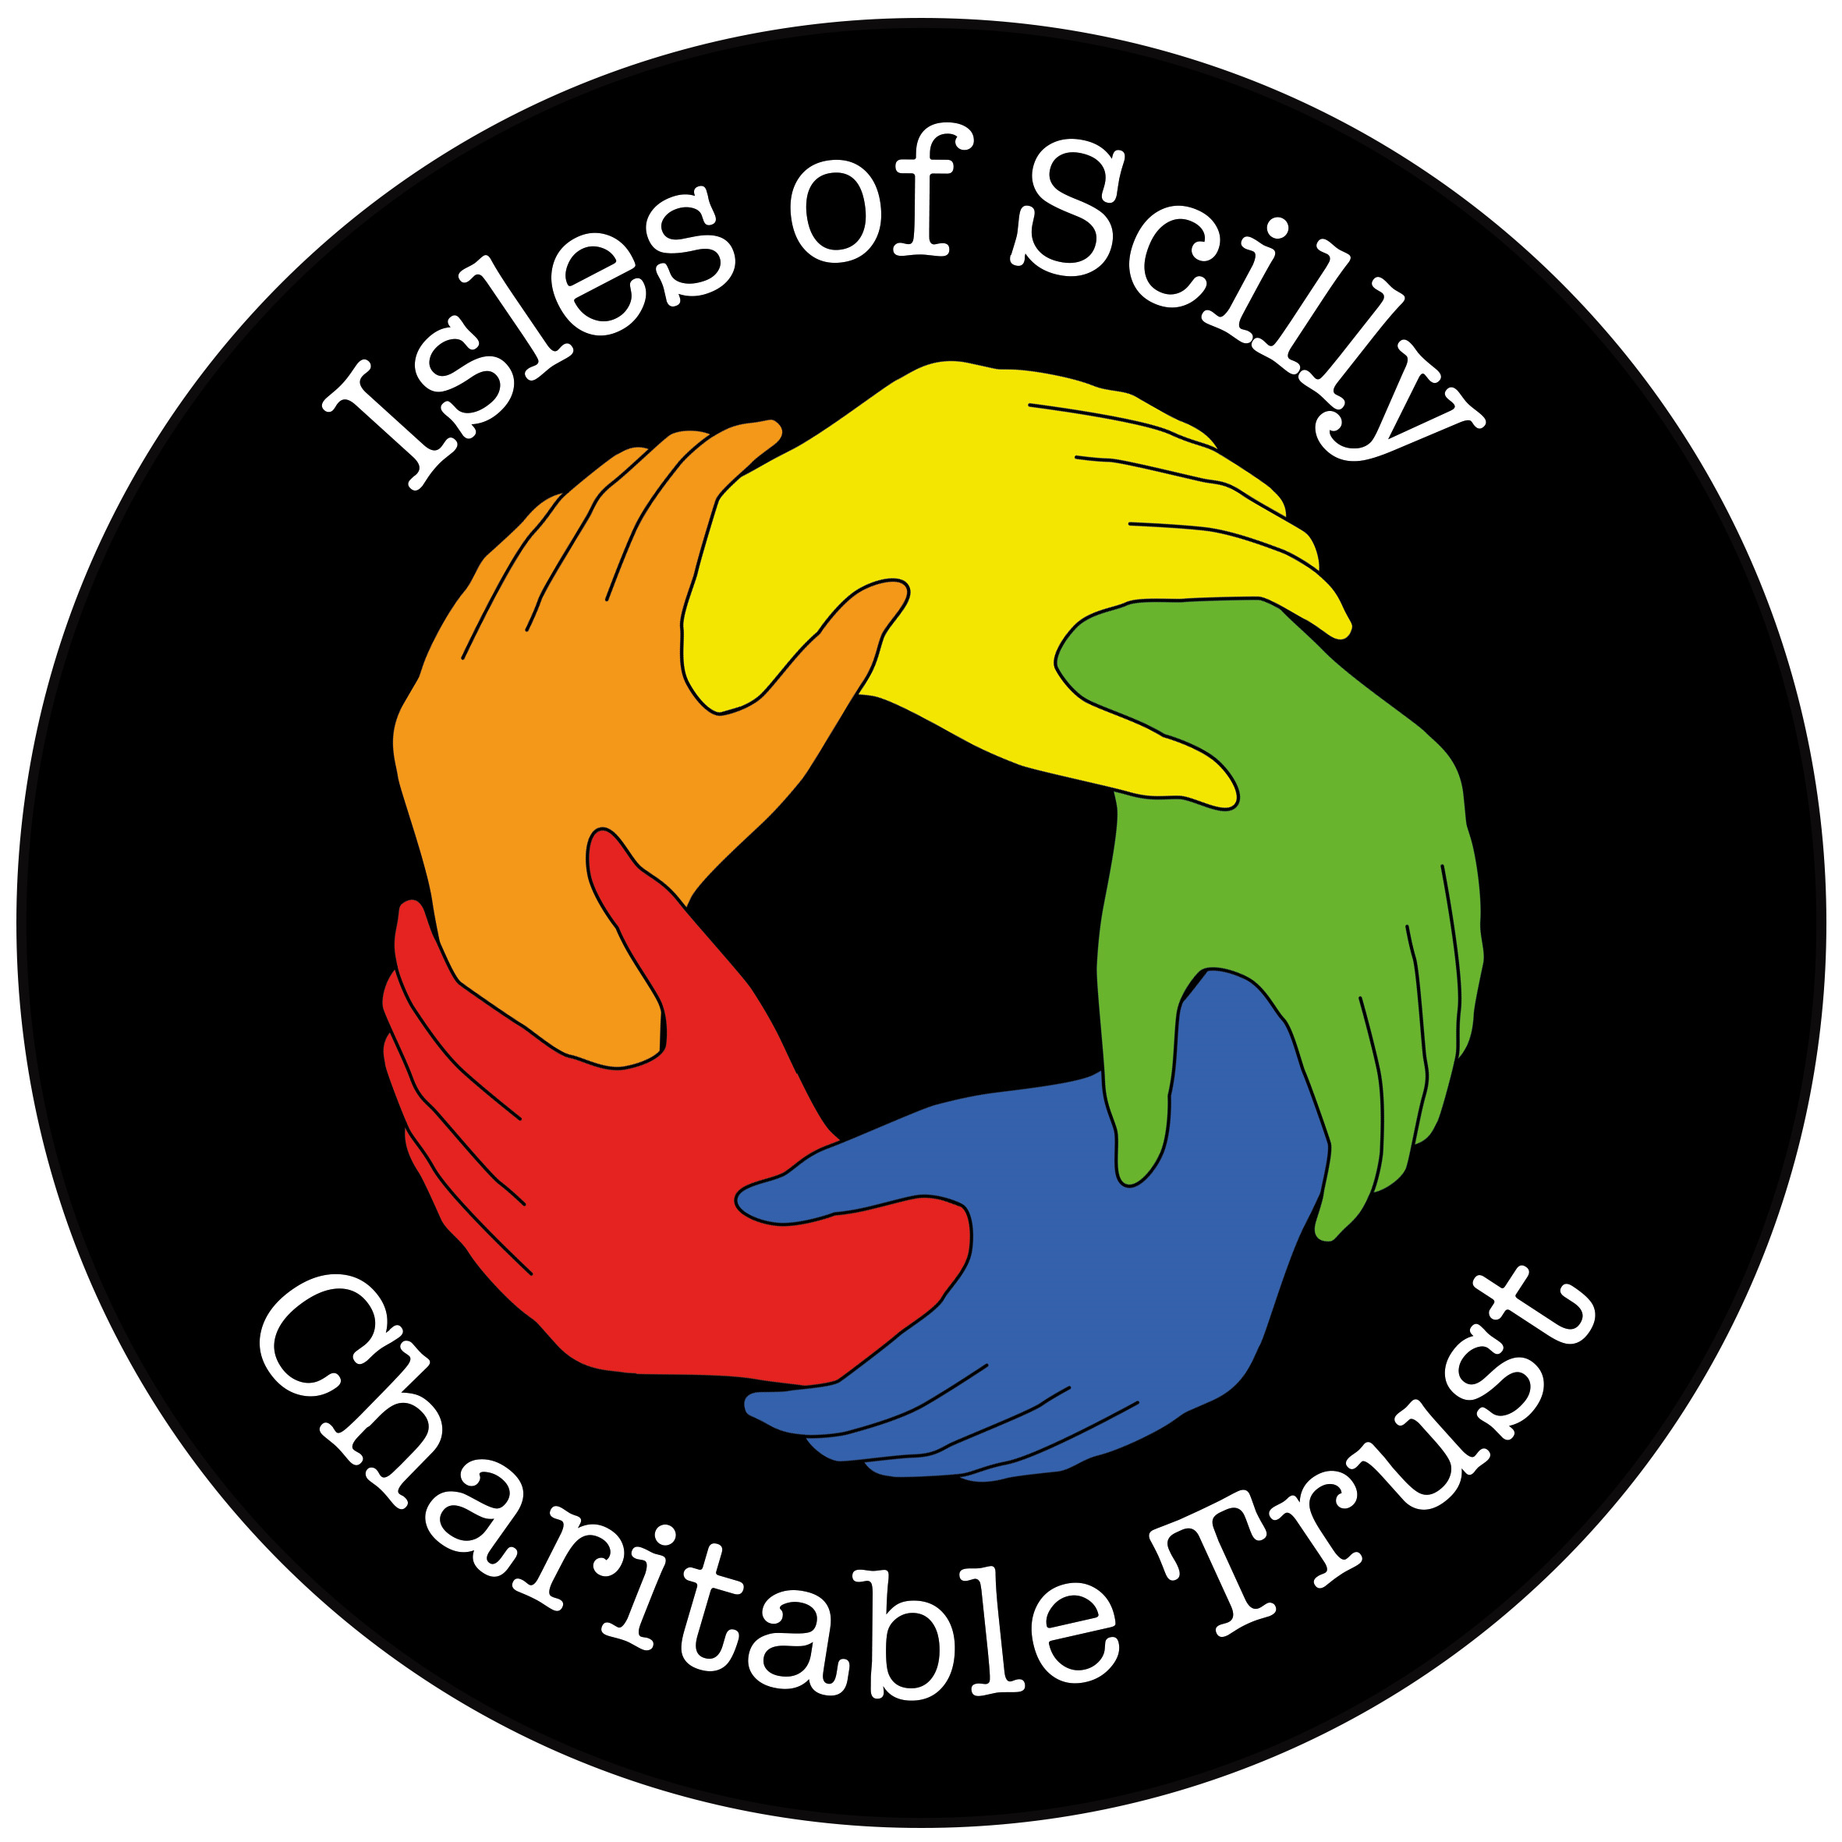
Isles of Scilly Charitable Trust
Application form for grant funding
SECTION 1: You can submit an application under one of three headings. Please tick below to let us know which one applies to your application and then proceed to the correct section.
1. | Financial support to address particular cases of hardship, in particular to support the health and wellbeing of people in need on the islands who are aged under 60 (please complete section 2 of this form on pp. 3-4)
2. | Financial support for on-island activities or events that will enrich the lives of local residents, in particular for the benefit of people aged under 60 (please complete section 3 of this form on pp. 5-6)
3. | Financial support for charitable purposes associated with maritime endeavours on the islands (please complete section 4 of this form on pp. 7-8)
Completed forms should be returned to Joseph Payne, Clerk to the Isles of Scilly Charitable Trust, at joseph.payne@scilly.gov.uk or at Carn Gwaval Wellbeing Centre, St Mary’s, Isles of Scilly, TR21 0NA.
You can view copies of our Statement of Purpose, our Privacy Notice and our most recent Annual Report and Accounts at www.scilly.gov.uk/charitable-trusts

THIS PAGE HAS BEEN LEFT BLANK TO FACILITATE DOUBLE-SIDED PRINTING

SECTION 2: APPLICATIONS FOR FINANCIAL SUPPORT TO ADDRESS PARTICULAR CASES OF HARDSHIP, IN PARTICULAR TO SUPPORT THE HEALTH OR WELLBEING OF PEOPLE IN NEED ON THE ISLANDS WHO ARE AGED UNDER 60
1. Details of the person completing this form
Name
Email
Telephone number
☐ If you are completing this application on behalf of someone else, please tick this box to confirm you have obtained their consent for sharing their personal information with us

If you are a professional person submitting this application as part of your job, please provide the additional details below
Organisation
Your job title
2. Details of the intended beneficiary/beneficiaries of this application
Name
If you are submitting an application on your own behalf, please enter your name again here
Age
The Isles of Scilly Charitable Trust welcomes applications to support people in need aged under 60.
Applications to support people aged 60 or over should be directed to the Richard Addison Charitable Trust rather than the Isles of Scilly Charitable Trust.
Please explain why the intended beneficiary can be considered as a person in need

3. Details regarding the grant application
How much are you applying for?
Grants will not exceed £500 per household per year unless exceptional circumstances exist
Please explain how the proposed grant would support the health or wellbeing of the intended beneficiary

If there is anything else you would like to tell us, please include it here

Signature (of the person completing this form):
Date:

SECTION 3: APPLICATIONS FOR FINANCIAL SUPPORT FOR ON-ISLAND ACTIVITIES OR EVENTS THAT WILL ENRICH THE LIVES OF LOCAL RESIDENTS, IN PARTICULAR FOR THE BENEFIT OF PEOPLE AGED UNDER 60
1. Details of the applicant
Name
Email
Telephone number
Organisation
Your role within the organisation
The trustees will not usually consider applications where commercial operators will be the principal beneficiaries.
Annual payments are made automatically to the Parochial Church Council of the Isles of Scilly, the Five Islands Academy, the Shipwrecked Mariners’ Society and the St Mary’s Christmas Lights Fund. No further grants will be awarded to these organisations unless exceptional circumstances exist.
2. Details regarding the grant application
How much are you applying for?
Grants will not exceed £500 per organisation per year unless exceptional circumstances exist
Which on-island activity or event is this application intended to support?
Did you receive IOSCT funding for the same activity or event last year?
The trustees will not usually support the same activity or event for two years in a row
When will this on-island activity or event take place?
Please provide details of the number and range of people who are likely to benefit from this on-island activity or event
Are the principal beneficiaries of this on-island activity or event aged under 60?
The Isles of Scilly Charitable Trust welcomes applications for activities or events where people aged under 60 will be the principal beneficiaries.
Applications for activities or events where people aged 60 or over will be the principal beneficiaries should be directed to the Richard Addison Charitable Trust rather than the Isles of Scilly Charitable Trust.
How will the on-island activity or event enrich the lives of local residents?

What is the total cost of this on-island activity or event?
How will you cover the rest of the cost of this on-island activity or event?
What safeguarding arrangements do you have in place for children and vulnerable adults (if applicable)?
If there is anything else you would like to tell us, please include it here

Signature:
Date:
SECTION 4: APPLICATIONS FOR FINANCIAL SUPPORT FOR CHARITABLE PURPOSES ASSOCIATED WITH MARITIME ENDEAVOURS ON THE ISLANDS
1. Details of the applicant
Name
Email
Telephone number
Organisation (if applicable)
Your role within the organisation (if applicable)
The trustees will not usually consider applications where commercial operators will be the principal beneficiaries.
As an exception to this, the Trust will continue to make a contribution towards the cost of life-saving equipment and the cost of training for local fishermen – in recognition of the long-standing relationship that it has with the fishing industry.
2. Details regarding the grant application
How much are you applying for?
How would the grant be used for a charitable purpose associated with maritime endeavours on the islands?

What is the total cost of your project (if applicable)?
How will you cover the rest of the cost of your project (if applicable?
What safeguarding arrangements do you have in place for children and vulnerable adults (if applicable)?
If there is anything else you would like to tell us, please include it here

Signature:
Date:

