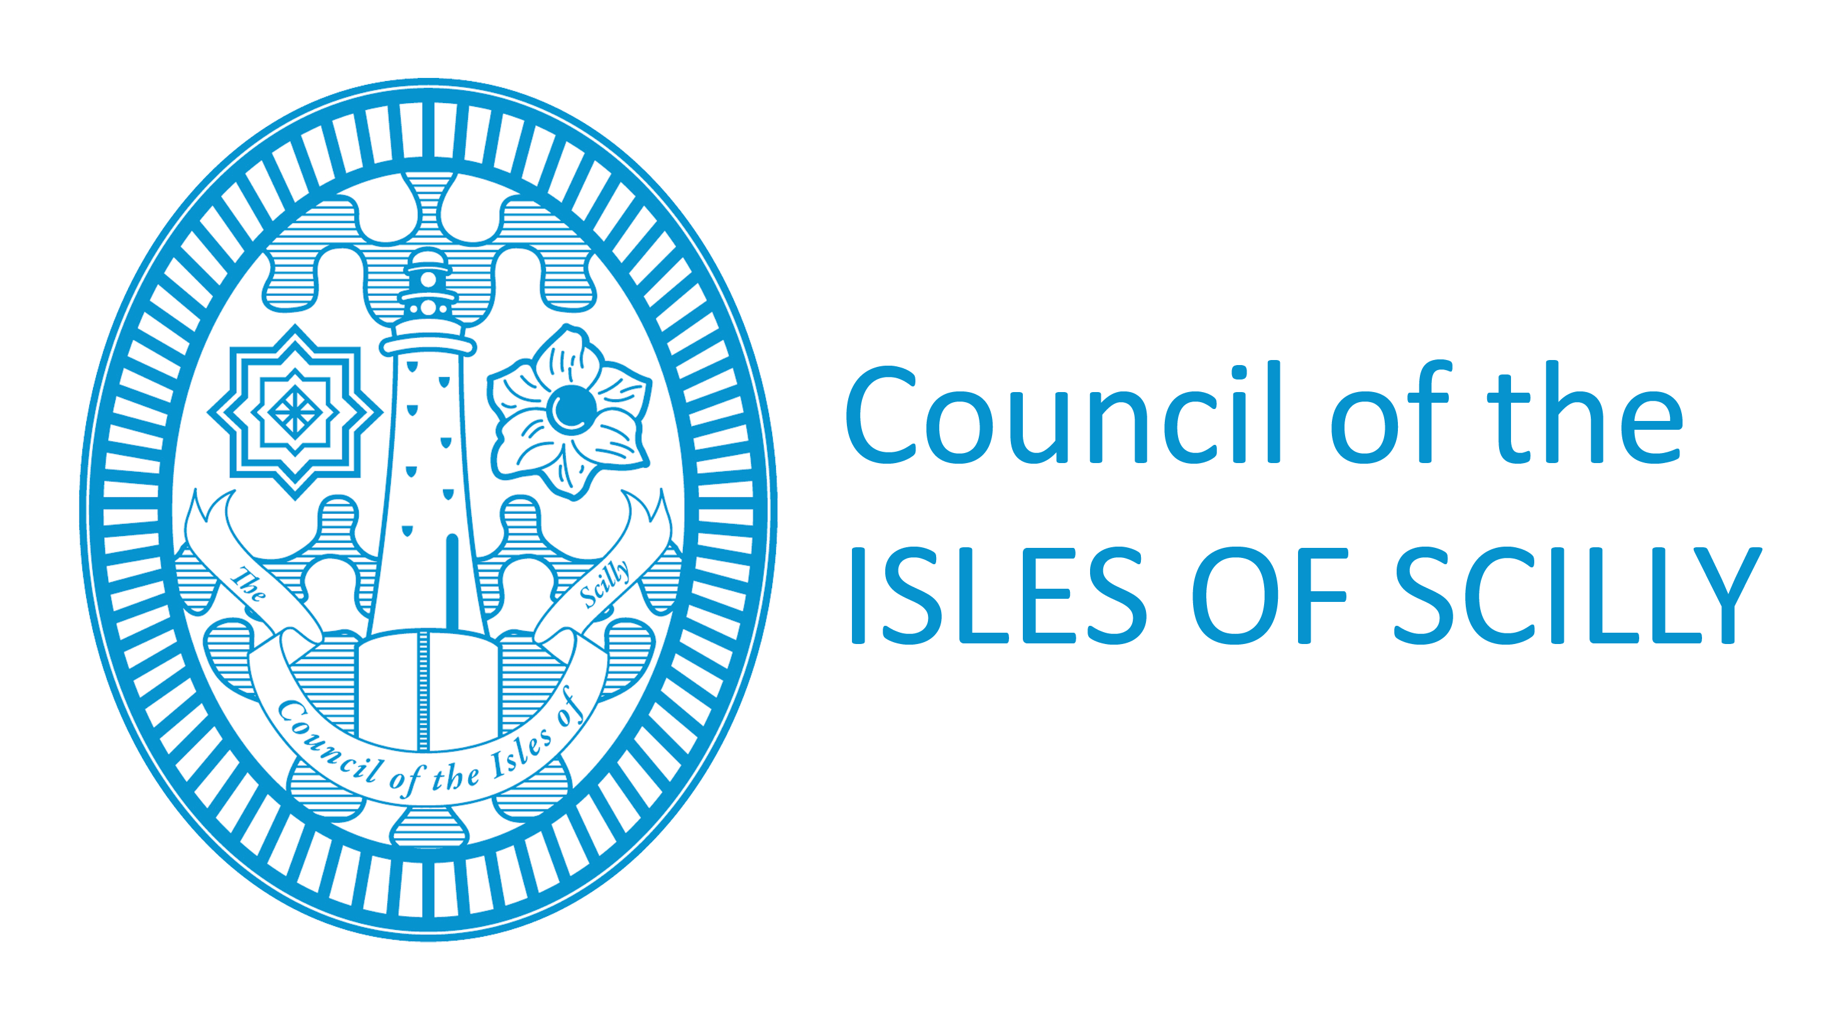
Licensing Department
Town Hall
St Mary’s
Isles of Scilly
TR21 OLW
Tel: 01720 424016/008
Fax: 01720 422202
licensing@scilly.gov.uk

Notification by Personal Licence holder of a change of name or address

PLEASE READ THE FOLLOWING INSTRUCTIONS FIRST
If you are completing this form by hand please write legibly in block capitals. In all cases ensure that your answers are inside the boxes and written or typed in black ink. Use additional sheets if necessary. You are advised to keep a copy of the completed form for your records.

1. YOUR PERSONAL DETAILS

Title (delete as appropriate): Mr Mrs Miss Ms Other (please state)

Surname:

Forenames:

Details of Personal Licence Held:
Licence No.
Date of Expiry

Previous Name(S) (if applicable)

Title (delete as appropriate): Mr Mrs Miss Ms Other (please state)

Previous Surname:

Previous Forenames:

2. NEW ADDRESS WHERE ORDINARILY RESIDENT

(We will use this address to correspond with you unless you complete the separate correspondence box below).

Post Town |  |  |  |  | Post Code

Telephone Numbers
Daytime |  |  |  |  |  | Evening
Mobile |  |  |  |  |  | Fax
Email
Effective From: |  |  |  | Immediately |  | ……………………………………………..  (Insert Date)

Address for correspondence associated with this application (if different to the address above)

Post Town |  |  | Post code
3. PREVIOUS ADDRESS
Post Town |  |  | Post code
4. DETAILS OF ANY NEW CRIMINAL CONVICTIONS
5. PLEASE COMPLETE THIS SECTION IF YOU ARE NOMINATED AS A PREMISES
SUPERVISOR ON A PREMISES LICENCE
Name of Premises:
Address of Premises:

Premises License No: |  | Issuing Local Authority:
6. CHECKLIST:
Please tick yes
- I have enclosed my Personal Licence (If you have not enclosed your personal licence, please give reasons below)
- I have enclosed my Personal Licence ID Card (If you have not enclosed your personal licence badge, please give reasons below)
- I have enclosed payment of £10.50 – (make cheques payable to Council of the Isles of Scilly)
If you have not enclosed your personal licence or ID card please give reasons why.

7. DECLARATION

The information contained in this form is correct to the best of my knowledge and belief.
It is an offence knowingly or recklessly to make a false statement in or in connection with an application for the grant or renewal or change of address of a personal alcohol licence. (A person is to be treated as making a false statement if he produces, furnishes, signs or otherwise makes use of a document that contains a false statement.) To do so could result in prosecution and a fine not exceeding level 5 on the standard scale.
SIGNATURE |  |  |  | DATE

