Sharing information
There may be time when the person you talked to has to share information. This includes:
- If they think a child is at risk of harm.
• If they think the information could help prevent or detect a serious crime.
Social care won’t get involved unless one of these things happens, or unless the circumstances in your family change and become more serious.
Remember, it’s your choice to have early help. It is just to help you and your family stop small problems turning into big problems – and hopefully into no problems at all.
What can I do next?
If you’d like to find out more about early help, talk with someone in your life that you trust.
You can ring any of the numbers below
Children’s Social Care 01720 424483
Health Visitor/School Nurse 01720 423722
GP 01720 422628
Five Islands School 01720 424850
Children’s Centre 01720 423680
Local Police 01720 422444
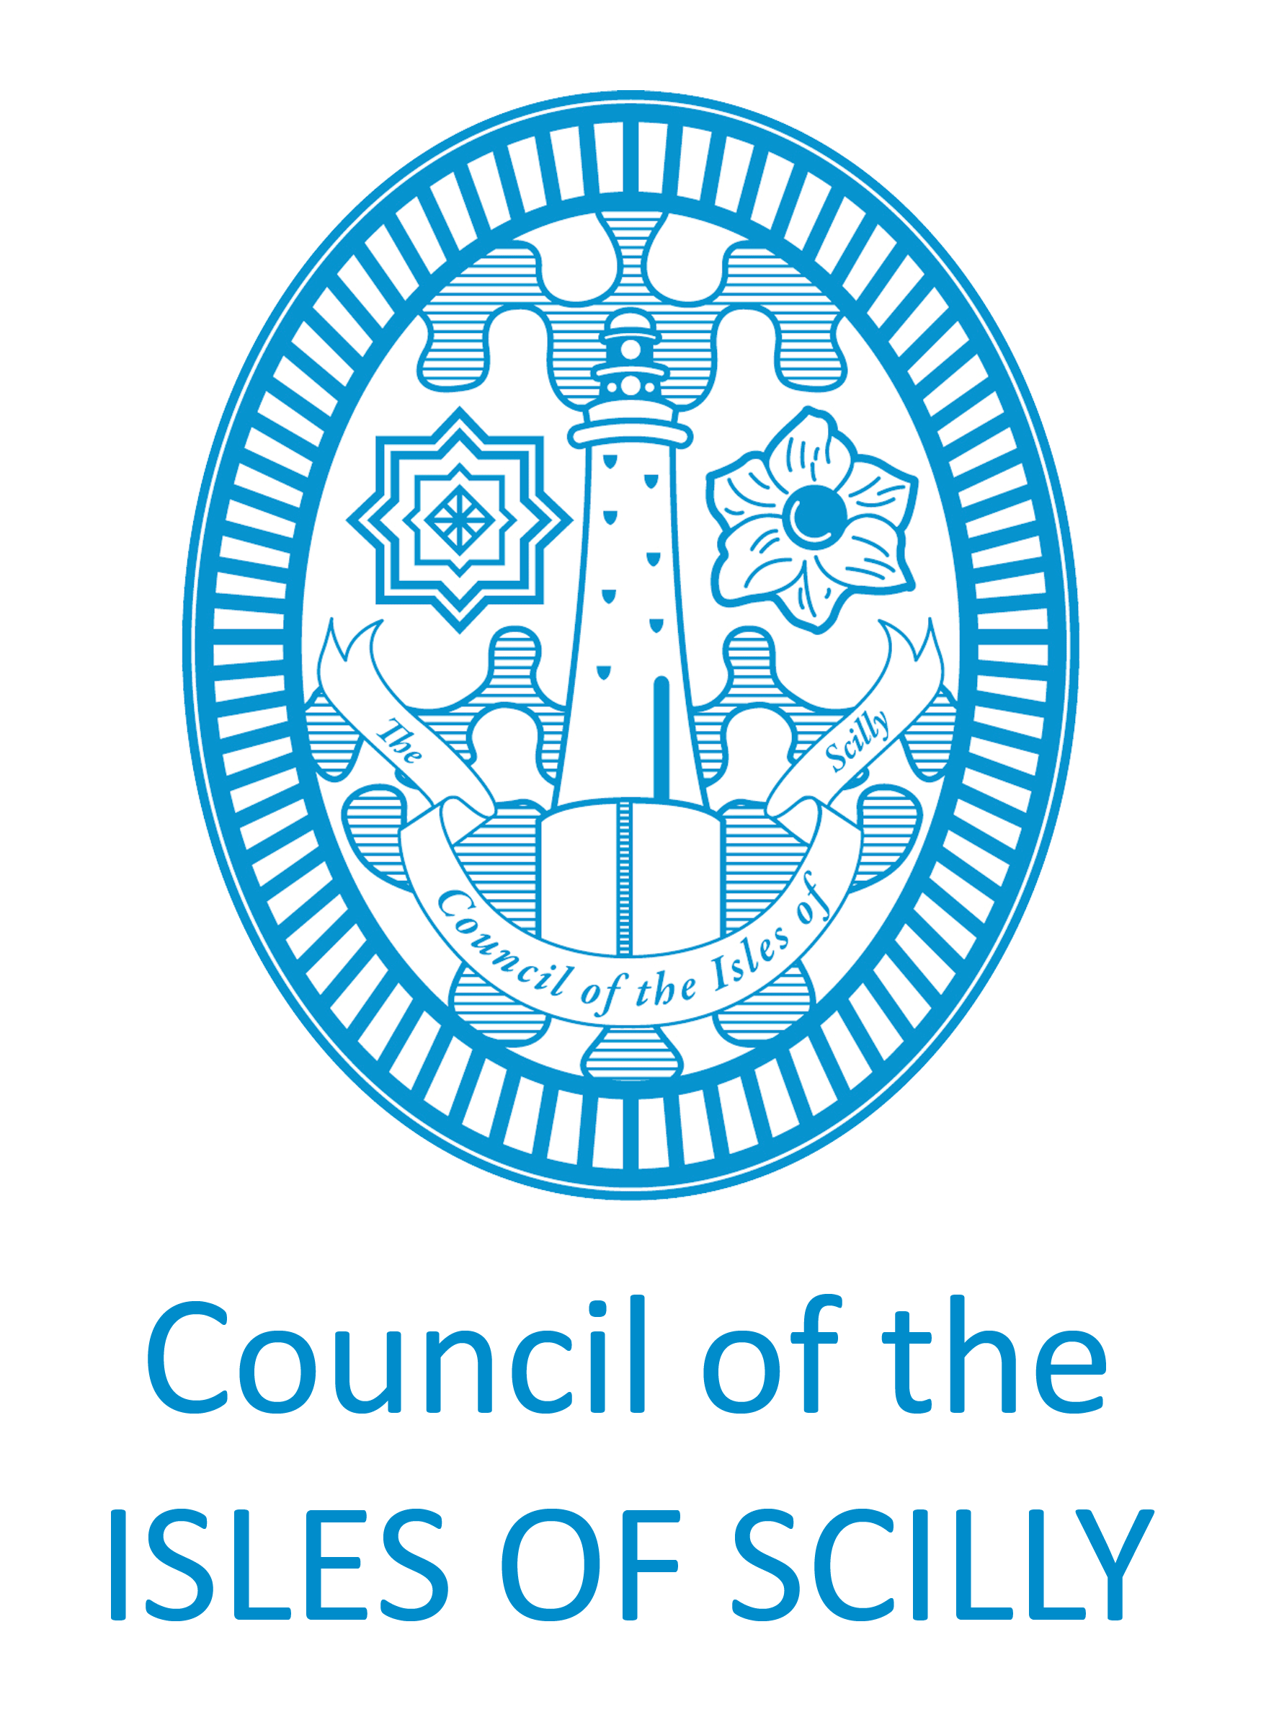
EARLY HELP ON THE ISLES OF SCILLY

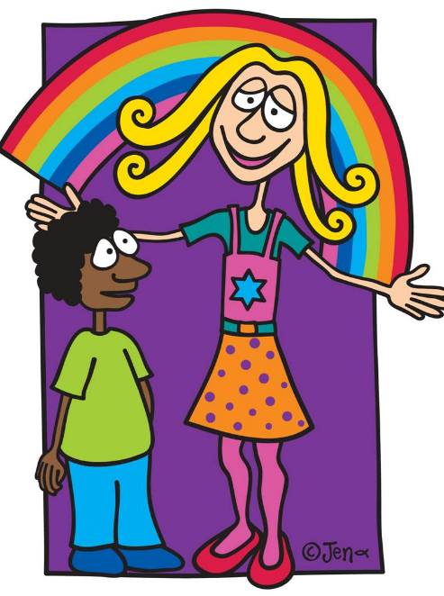

A GUIDE FOR PARENTS AND CARERS

What is early help?
Every family goes through challenging times at some point. Early help means working with you and your family so that small problems don’t become big problems. Early help is for everybody, for families with children and young people of any age. And it’s your choice whether to have it or not.
Why would I want early help?
There are lots of reasons why people look for early help. It could be that you’re worried about your child’s health, development or behaviour, or how they’re doing at school, or perhaps because you are caring for a disabled child. It may be that you’re worried about money or housing and how that is affecting your family. Maybe your child or your family is affected by domestic abuse, drugs or alcohol or crime. Perhaps your child is a carer for other people, or maybe you’ve had a bereavement in the family that’s made life a real challenge.
Where can I get early help?
If you feel you and your family might need support to solve some problems, you can ask someone in your life that you trust about early help. This might be a teacher or family support worker at your child’s school, your GP, your health visitor, pre-school/nursery worker. If you find this difficult, you can always contact Children’s Social Care. We’ll work with you to find someone for you to talk to. Sometimes if someone is worried that you’re having some problems, they might ask you if you would like to talk about early help.

What will happen if I ask for early help?
The person you trust in your life will talk with you about the problems you are experiencing. They will ask what help and support you think you might need. This is call an early help assessment and is nothing to be worried about. It’s just a conversation to work out how to help you stop small problem’s turning into bigger ones. You can talk about things that are going well and things that you’re proud of as well as things that you’re finding a challenge. This person will also talk with your child or children in your family to make sure they understand how they are feeling and anything they think they might want some help with. Together you’ll agree what to write down so there is a record of what you have talked about.
What happens next will be different for every family. You might make a plan with the person you spoke with to sort out the problems. You might want to meet with other people who might be able to help. This is called a team around the child/family meeting. You have control over what happens next and can say what you want. If you decide you’d like some help, the person you talked with will ask if they can share details of your conversation. You need to be happy with this and give your permission. This is to make sure the people who will be supporting you are able to do a good job for you and understand the journey you and your family have been on.

