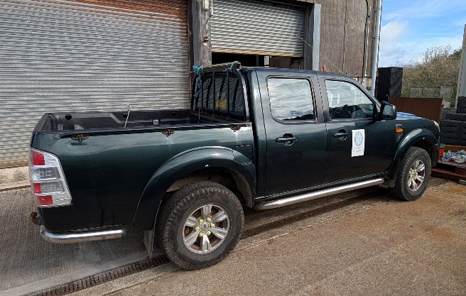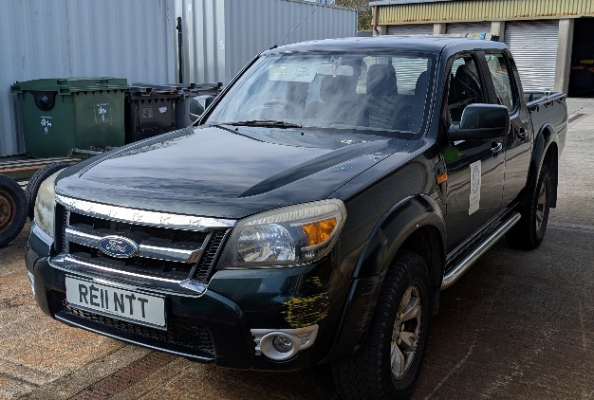

ITEM: Ford Ranger RE11NTT.

CONDITION: Sold as seen. Old vehicle, signs of wear and tear to bodywork, suitable for parts, or repair .

CLOSING DATE: 5pm, Thursday 4th December 2025

For more information, or to arrange an inspection of the item, please contact Environment@scilly.gov.uk or call 01720 424450

PLEASE NOTE: The Council of the Isles of Scilly makes no representations or warranties as to the fitness for purpose of the item(s) purchased. The purchaser is understood to have inspected the goods to make their own assessment as to their condition and suitability for future use. The winning bid is subject to VAT.

TO BE COMPLETED BY BIDDER:
NAME:
ADDRESS:

TELEPHONE:
EMAIL:
BID AMOUNT £
Final bid is subject to contract & VAT.
SIGNATURE: DATE:

