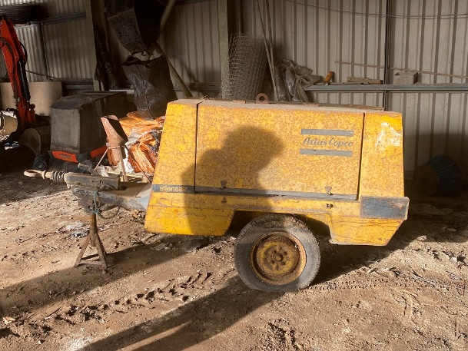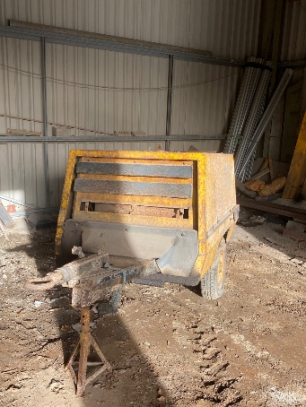

ITEM: Atlas Copco towable compressor & various associated tools.

CONDITION: Sold as seen. Old plant, signs of wear and tear to bodywork, suitable only for parts, or repair .

CLOSING DATE: 5pm, Thursday 16th February 2023

For more information, or to arrange an inspection of the item, please contact infrastructure@scilly.gov.uk or call 01720 424450

PLEASE NOTE: The Council of the Isles of Scilly makes no representations or warranties as to the fitness for purpose of the item(s) purchased. The purchaser is understood to have inspected the goods to make their own assessment as to their condition and suitability for future use.

TO BE COMPLETED BY BIDDER:
NAME:
ADDRESS:

TELEPHONE:
EMAIL:
BID AMOUNT £

SIGNATURE: DATE:

