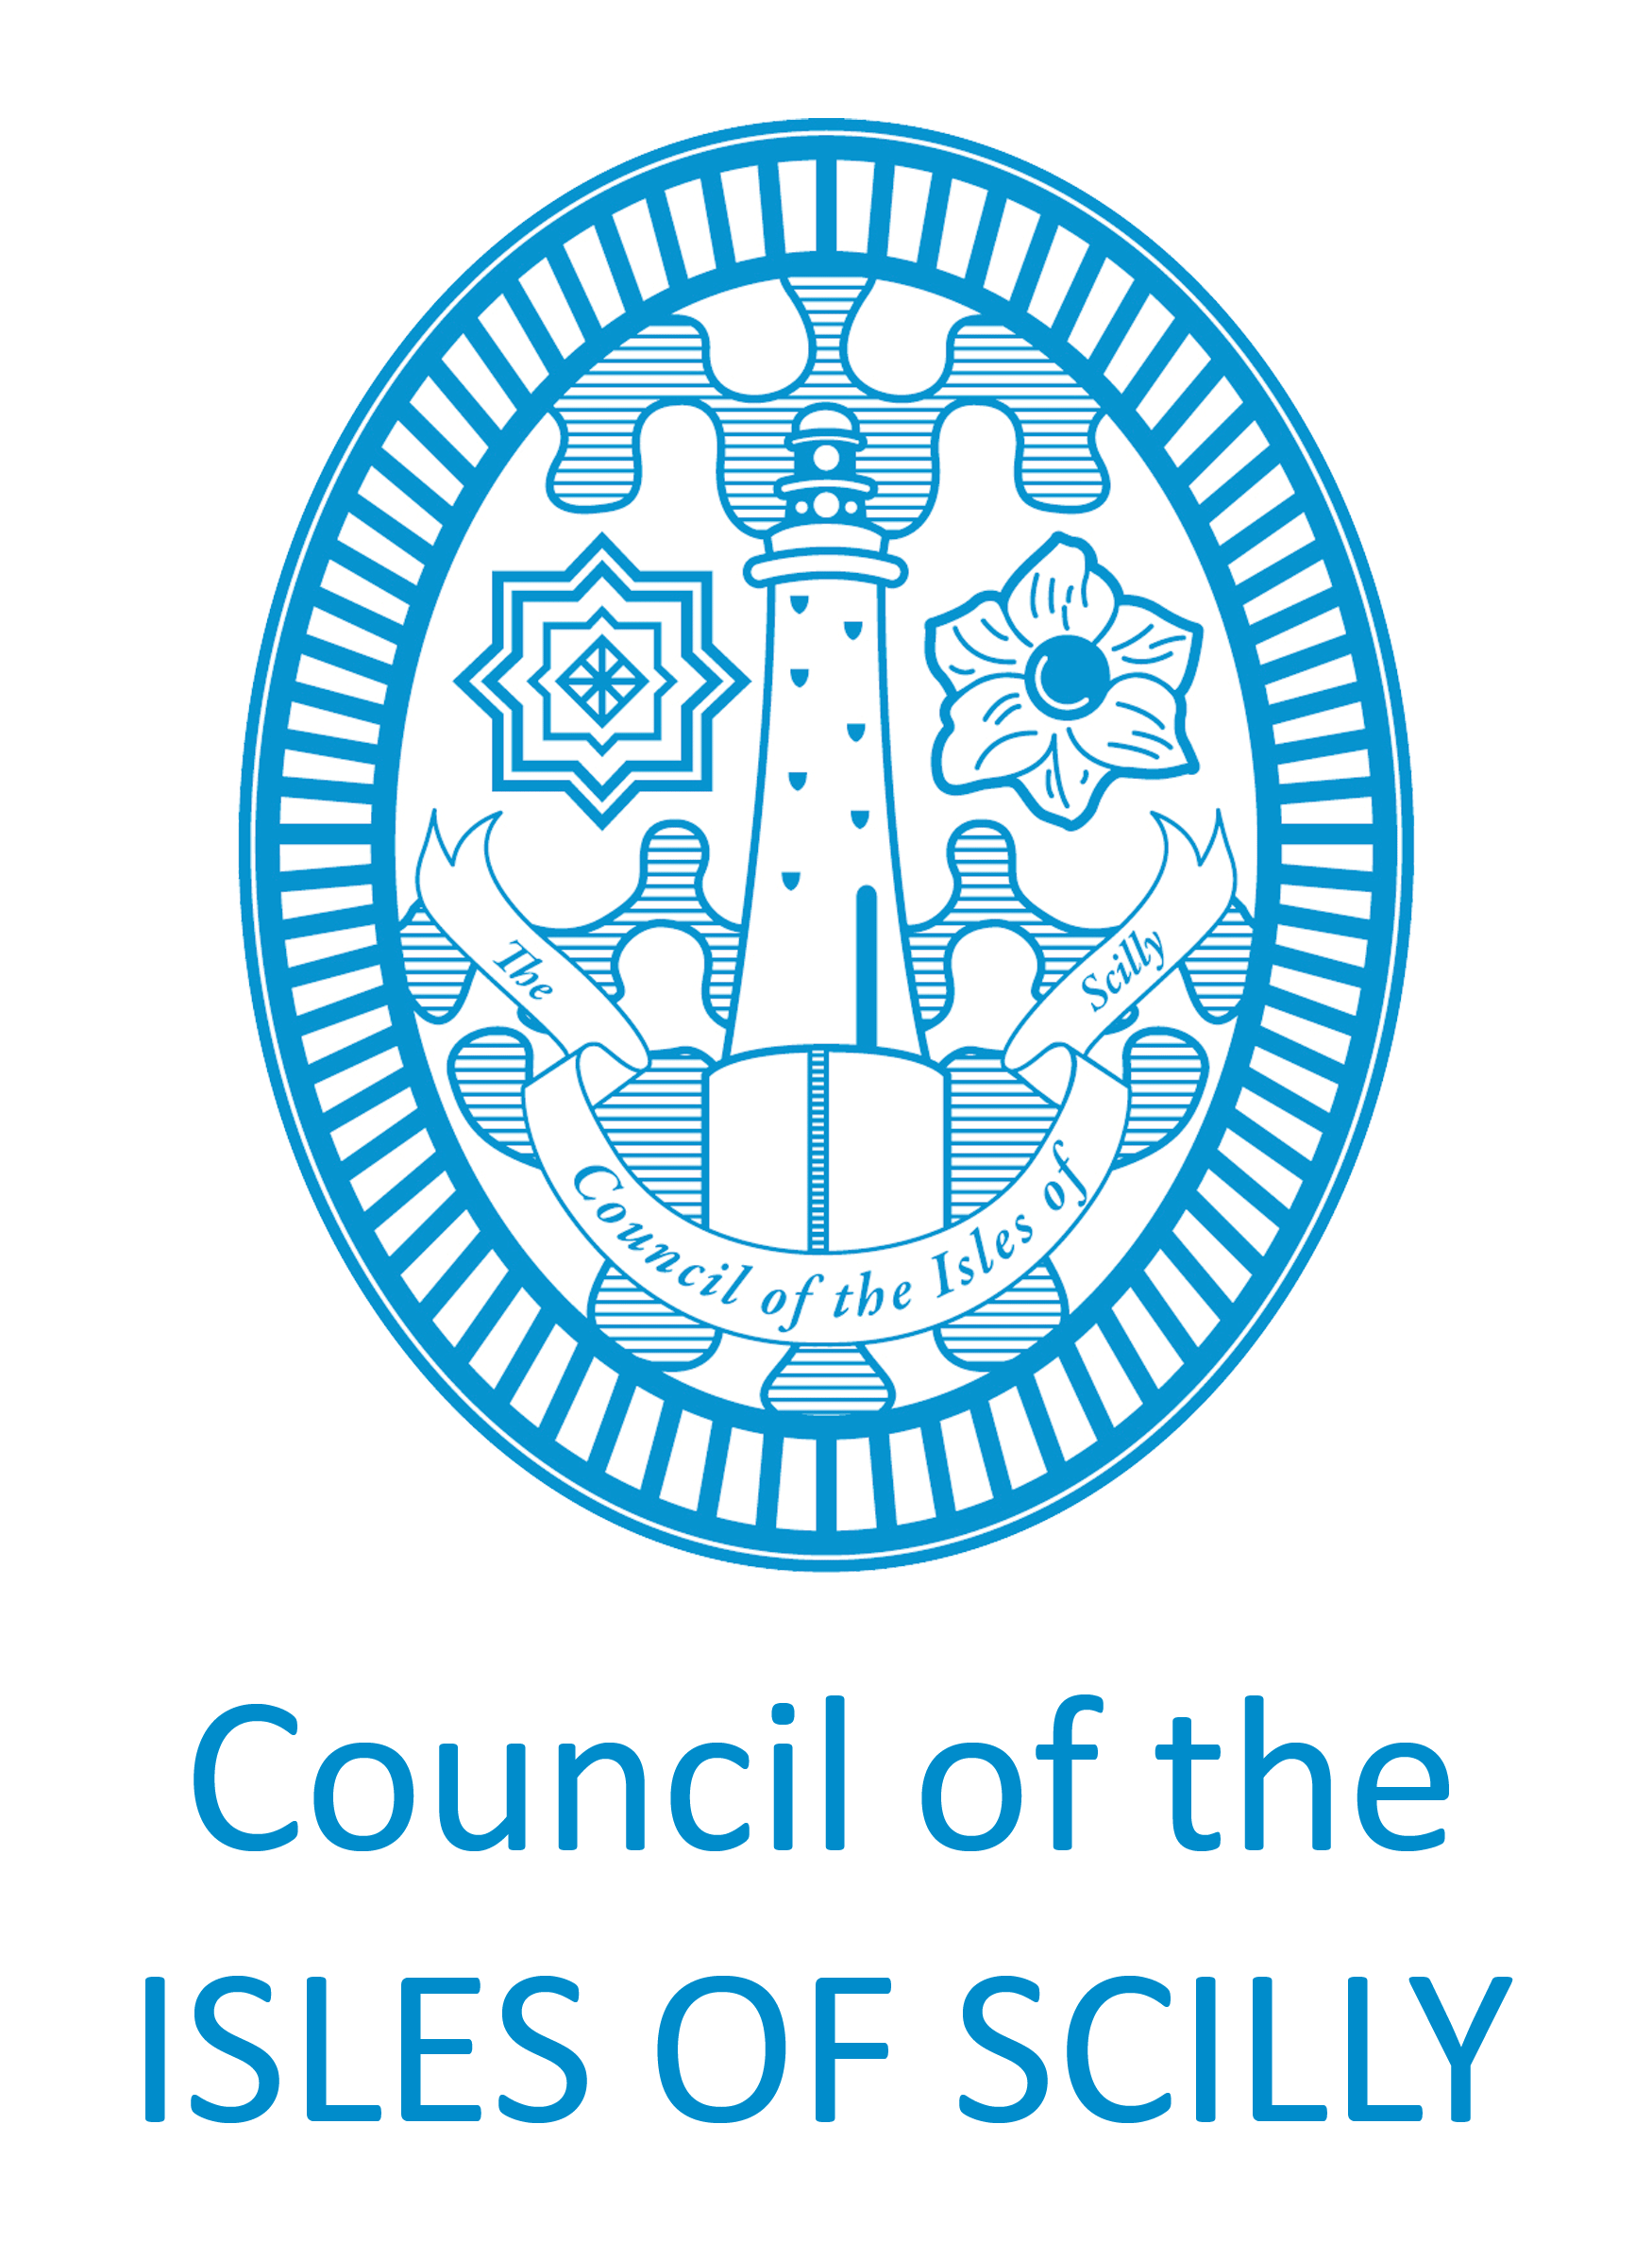
Please note this document does not have a named adult social care member of the team within it and is designed to show you what you will receive if you contact the team and request a care assessment

ADULT SOCIAL CARE WELCOME PACK

My name is and I am a Care Co-ordinator.
You can contact me on 01720 424470 or email me on asc@scilly.gov.uk
I am a member of the Adult Social Care Team who offer signposting and support to any adults on the Isles of Scilly.

What is an assessment?
An assessment is a discussion between yourself, a care co-ordinator and, if you wish, a family member, close friend or an independent advocate, to understand your situation and your needs. Together with your care co-ordinator you can explore what help and support can be provided and to maintain your independence and promote your wellbeing.

Personal Information
Any information about you will be recorded, with your consent, on our electronic system and may need to be shared with partner agencies such as the NHS. This is to ensure you get the most appropriate and best service. We will provide you with a copy of our Date Privacy document which will explain more about what data we collect, were we store it and who we will share it with.
If you have any comments or complaints about any aspect of the service you receive form us, please contact Scott Fuller on 01720 424472 or email on scott.fuller@scilly.gov.uk

